**INTERNSHIP REPORT**

Comprehensive analysis of amazon sales report

**Prepared by: Gawande Sahil Shivaji**

**Internship Duration: 25/05/2024 – 20/06/2024**

**Organization: Innobyte Services**

**Date: 7/06/2024**

DATA ANALYST INTERNSHIP

**INDEX**

1. **Introduction**
2. **Analysis**

* Sales overview
* Product analysis
* Fulfillment methods
* Customer segmentation
* Geographical analysis
* Insights and recommendation

1. **Conclusion**

**INTRODUCTION**

The e-commerce landscape has witnessed significant growth in recent years, with platforms like Amazon playing a pivotal role in shaping consumer behavior and retail trends. In this report, we present a comprehensive analysis of sales transactions on Amazon, aimed at extracting actionable insights to drive business decisions and enhance overall performance.

**Problem Statement:**

The provided dataset contains a wealth of information regarding sales transactions on Amazon, encompassing various aspects such as order details, dates, fulfillment methods, product categories, quantities, amounts, and more. The primary objective of this analysis is to delve deep into the dataset, uncover meaningful patterns, and provide insights that can be leveraged to optimize business operations and improve customer satisfaction.

**Dataset Description:**

The dataset encompasses a range of variables crucial for understanding Amazon sales dynamics. It includes order IDs, dates, statuses, fulfillment methods (e.g., FBA, FBM), sales channels, product categories, sizes, quantities, amounts, shipping details, and additional attributes. This rich dataset provides us with the opportunity to explore various dimensions of Amazon sales performance.

**Objectives:**

* **Sales Overview:** Understand the overall sales performance, trends, and patterns over time.
* **Product Analysis:** Analyze the distribution of product categories, sizes, and quantities sold to identify popular products.
* **Fulfillment Analysis**: Investigate the effectiveness of different fulfillment methods in delivering orders.
* **Customer Segmentation:** Segment customers based on their buying behavior, location, and other relevant factors.
* **Geographical Analysis:** Explore the geographical distribution of sales, focusing on states and cities.
* **Business Insights:** Provide actionable insights and recommendations to optimize sales strategies, improve customer satisfaction, and enhance overall business performance.

**ANALYSIS**

1. **Sales Overview**
2. **Monthly Sales Trend**

**Total Monthly Sales:** Calculate the total sales for each month to identify the overall trend.

**Average Monthly Sales:** Compute the average monthly sales to understand the typical performance.

**Peak Sales Months:** Identify months with the highest and lowest sales.

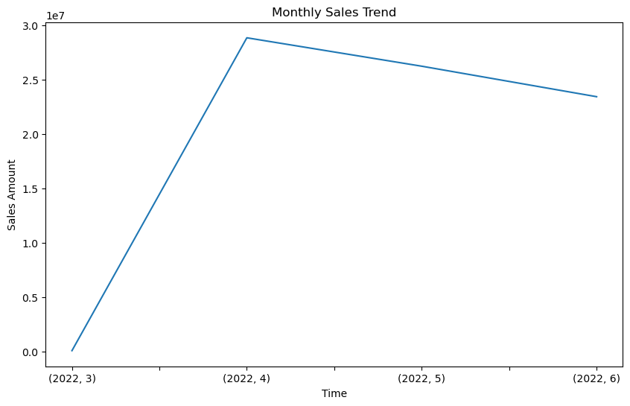

**Key Findings:**

* Identify any overall increasing or decreasing trends in monthly sales.
* Highlight months with the highest and lowest sales volumes.
* Determine any seasonal patterns or trends over the months.

1. **Daily Sales Trend**

**Total Daily Sales:** Calculate the total sales for each day to identify daily fluctuations.

**Average Daily Sales:** Compute the average daily sales to understand regular patterns.

**Sales Variation:** Analyze sales variations throughout the week.

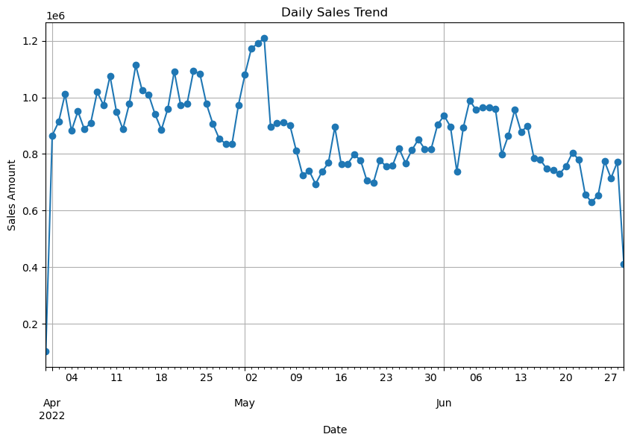

**Key Findings:**

* Analyze daily fluctuations in sales to identify peak days.
* Determine if there are any consistent patterns throughout the week.
* Identify any anomalies or irregularities in daily sales.

1. **Product Analysis**
2. **Product Category Distribution:**

**Distribution of Product Categories:** Calculate the percentage of sales contributed by each product category.

**Visualize:** Represent the distribution using a pie chart or bar graph to show the proportion of sales for each category.

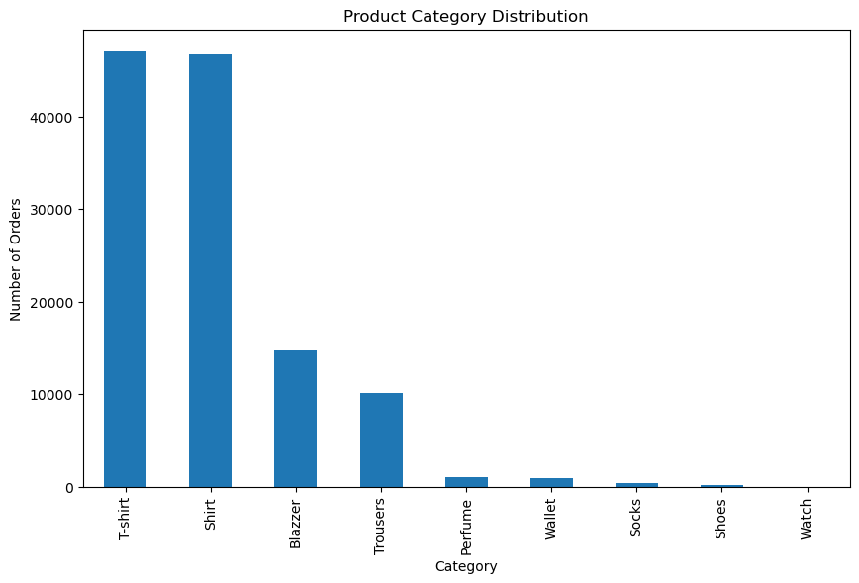

**Insights:**

* Identify which product categories contribute the most to overall sales.
* Determine the popularity of different product categories among customers.

**b. Product Size Distribution:**

**Distribution of Product Sizes:** Analyze the distribution of product sizes sold.

**Visualize:** Use a bar graph or histogram to represent the distribution of product sizes.

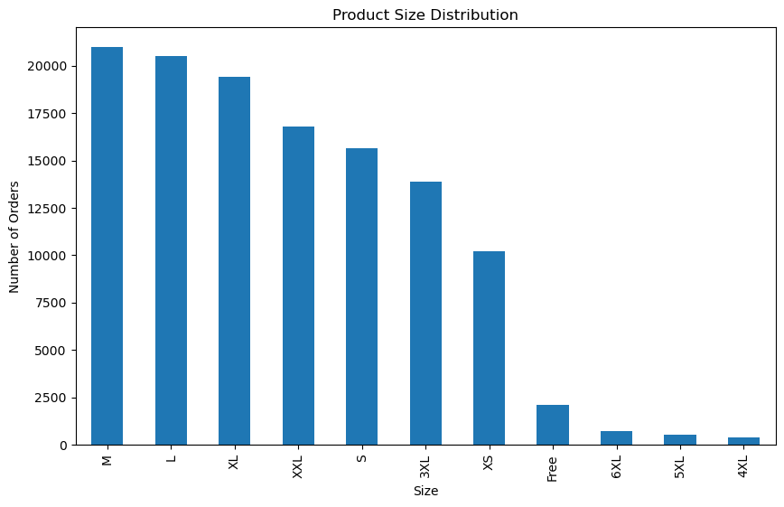

**Insights:**

* Identify which product sizes are most commonly sold.
* Determine if there are any size preferences among customers.

**c. Top 10 Products by Quantity Sold**

**Identify Top Selling Products:** Determine the top 10 products based on the quantity sold.

**Visualize:** Create a bar chart to display the quantity sold for each of the top products.

**Insights:**

* Identify the best-selling products in terms of quantity.
* Understand which products are most in demand among customers.

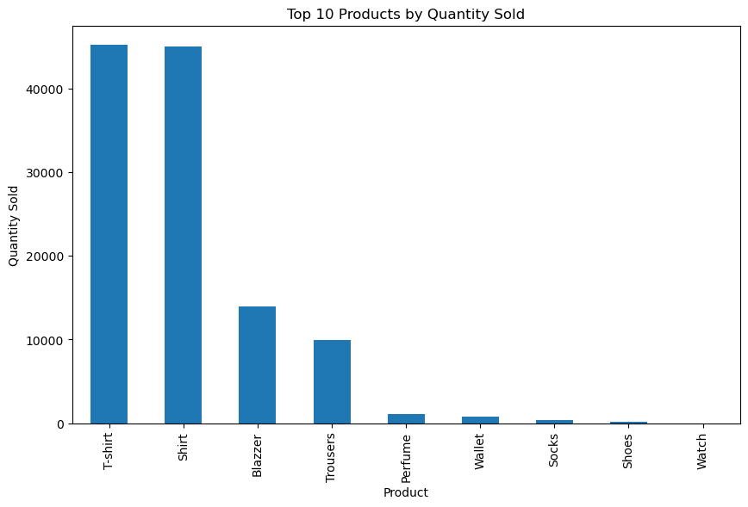

**d. Top 10 Products by Sales Amount:**

**Identify Top Revenue Generating Products:** Determine the top 10 products based on sales amount.

**Visualize:** Create a bar chart to display the sales amount for each of the top products.

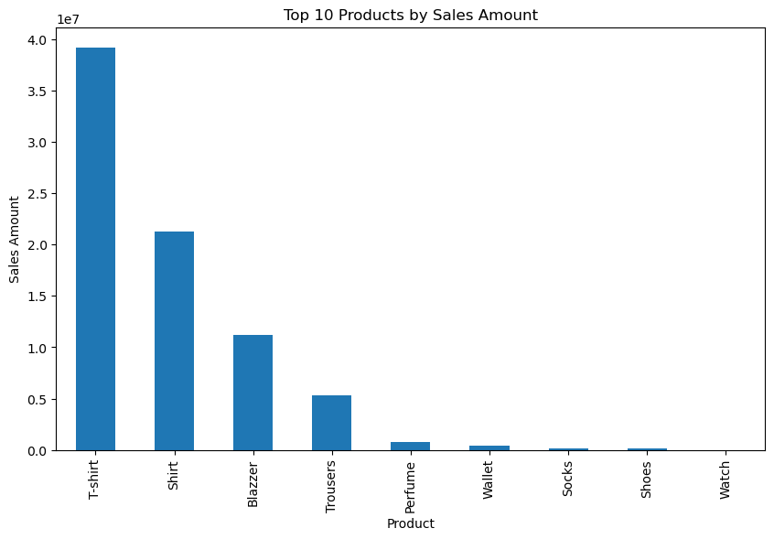

**Insights:**

* Identify the top revenue-generating products.
* Understand which products contribute the most to the overall sales revenue.

1. **Fulfillment Methods**

**Comparison of Fulfillment Methods:** Analyze the distribution of orders fulfilled by Amazon (FBA) and Merchant Fulfillment.

**Visualize:** Create a bar chart to compare the number of orders fulfilled by each method.

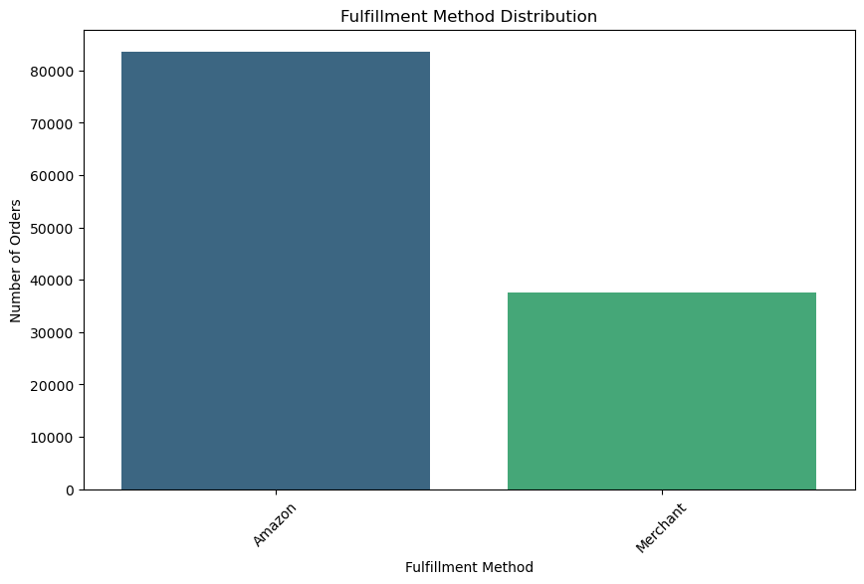

**Insights:**

* Determine the proportion of orders fulfilled by Amazon and Merchant Fulfillment.
* Assess the effectiveness of each fulfillment method in completing orders.

**Key Findings:**

* **Amazon (FBA):** Number of orders fulfilled by Amazon's Fulfillment by Amazon service.
* **Merchant:** Number of orders fulfilled by Merchant Fulfillment.

**4. Customer Segmentation:**

**a. Delivery Performance Segmentation:**

**Segmentation based on Courier Status:** Segment customers based on the status of their orders (Shipped, Unshipped, On the Way).

**Visualize:** Create a pie chart or bar chart to illustrate the distribution of customers in each segment.

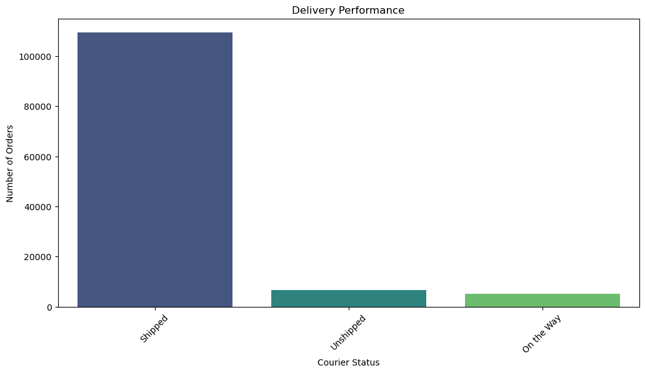

**Insights:**

* Understand the distribution of customers based on their order delivery status.
* Assess the impact of delivery performance on customer satisfaction and retention.

**b. Spending Segments:**

**Segmentation based on Spending:** Segment customers into spending segments

**Visualize:** Create a bar chart to show the distribution of customers across spending segments.

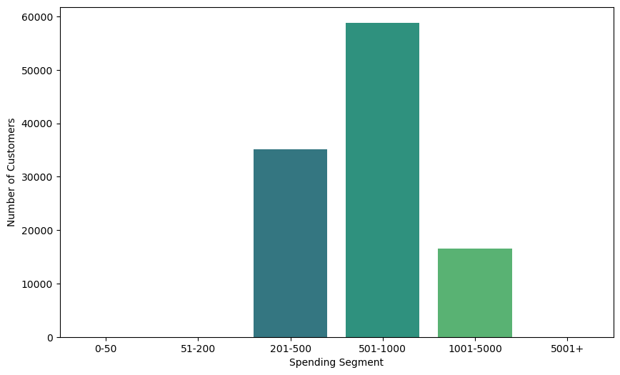

**Insights:**

* Identify different groups of customers based on their spending behavior.
* Understand the contribution of each spending segment to overall revenue.
  1. **Geographical Analysis**:

1. **Sales by State:**

**Sales Distribution by State:** Analyze the total sales for each state.

**Visualize:** Create a bar chart or geographical map to illustrate sales distribution across states.

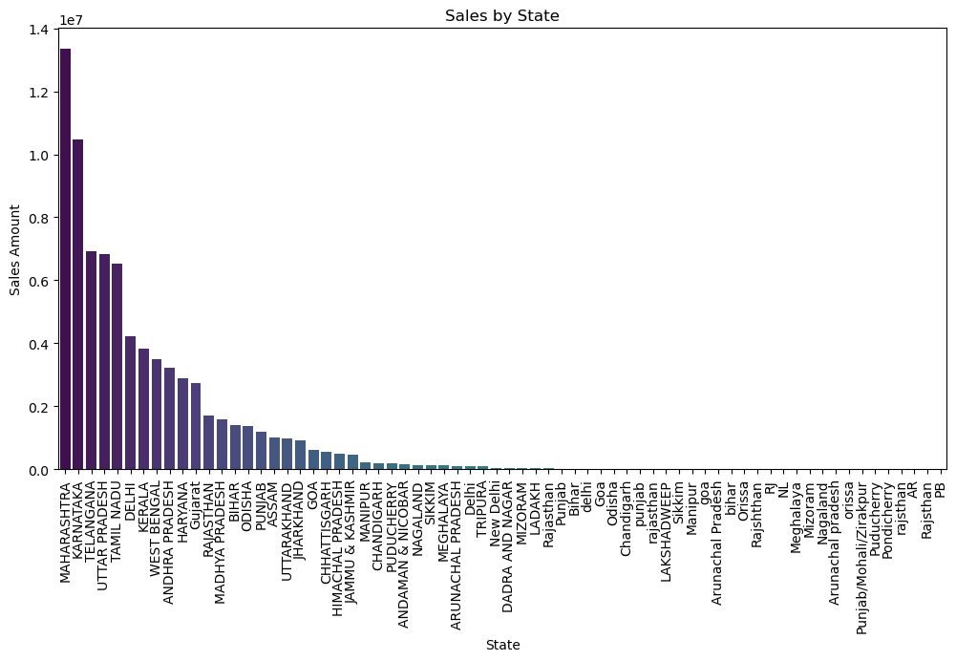

**Insights:**

* Identify states with the highest and lowest sales volumes.
* Understand regional sales patterns and trends.

1. **Top 20 Cities by Sales:**

**Identify Top 20 Cities:** Determine the top 20 cities with the highest sales.

**Visualize:** Create a bar chart to show sales amount for each of the top cities.

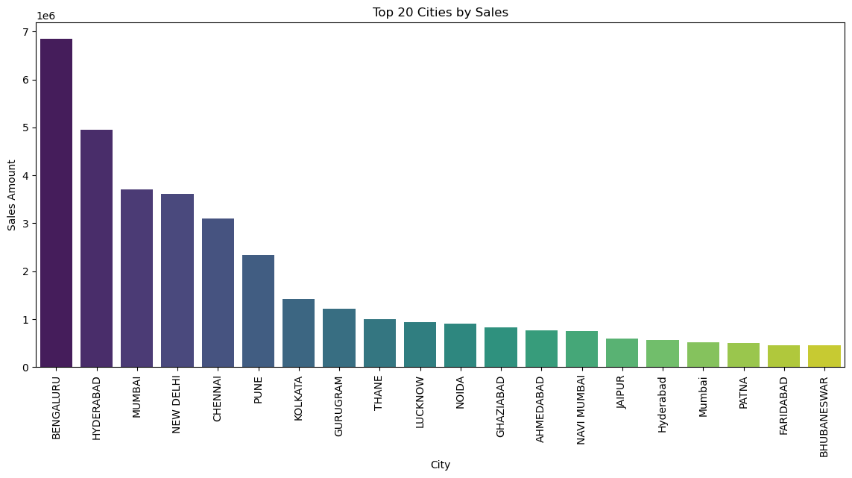

**Insights:**

* Identify major cities contributing significantly to sales.
* Understand the geographical concentration of sales.
  1. **Business Insights and Recommendations**

#### **Total Sales and Orders:**

* **Total Sales:** 78590170.24999999 indicates the overall revenue generated.
* **Total Orders:** 112887 reflects the transaction volume.

#### **Average Order Value and Sales Growth:**

* **Average Order Value:** With an average order value of 648.56, efforts can be made to increase this value through upselling or cross-selling strategies.
* **Sales Growth Rate:** The sales have grown at a rate of 22937.88 over the analyzed period.

#### **Product Categories:**

* **Top Product Categories:** The top 5 product categories by sales volume are [*'T-shirt', 'Shirt', 'Blazzer', 'Trousers', 'Perfume'*]. Focus on maintaining sufficient inventory for these categories.

#### **Fulfillment Method:**

* **Top Fulfillment Method:** The most commonly used fulfillment method is Amazon. Ensure optimization and efficiency in fulfillment processes.

#### **Customer Segments:**

* **Top Customer Segment:** Target high-value customer segments identified to drive repeat purchases and increase customer loyalty.

#### **Geographic Sales Distribution:**

* **Top Selling States:** The top 5 states by sales volume are [*'MAHARASHTRA', 'KARNATAKA', 'TELANGANA', 'UTTAR PRADESH', 'TAMIL NADU'*]. Allocate resources and marketing efforts accordingly.
* **Top Selling Cities:** The top 5 cities by sales volume are [*'BENGALURU', 'HYDERABAD', 'MUMBAI', 'NEW DELHI', 'CHENNAI'*]. Concentrate marketing campaigns in these cities for better reach.

### Recommendations:

* **Increase inventory:** Ensure sufficient stock for top-selling products and categories to meet customer demand.
* **Optimize fulfillment:** Improve fulfillment strategies based on performance analysis to ensure timely delivery and customer satisfaction.
* **Target high-value segments:** Tailor marketing efforts to target high-value customer segments identified to maximize revenue.
* **Focus on top-performing regions:** Allocate marketing resources to top-selling states and cities to capitalize on high-demand areas.

**CONCLUSION**

The comprehensive analysis of the Amazon sales report has provided valuable insights that can be leveraged to optimize business operations, enhance customer experience, and drive revenue growth. By understanding sales trends, product preferences, fulfillment effectiveness, customer segments, and geographical distribution, businesses can make informed decisions to stay competitive in the e-commerce market.

Moving forward, continuous monitoring of sales performance, customer behavior, and market trends will be essential for adapting strategies and maintaining business success in the dynamic e-commerce landscape.

Through data-driven insights and strategic actions, the aim is to continuously improve sales strategies, streamline operations, and ultimately, deliver exceptional value to customers while driving business growth.